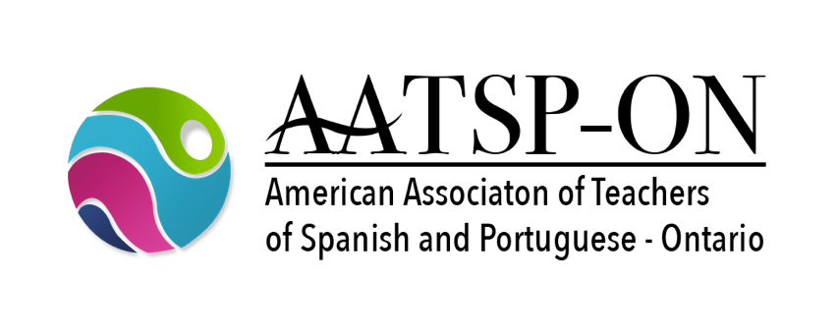 | 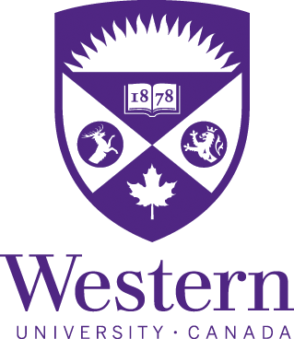

CALL FOR PAPERS

The American Association of Teachers of Spanish and Portuguese - Ontario Chapter
ANNUAL CONFERENCE
Imagining our Future: Challenges in Teaching Language and Literature in Canada

IN PERSON - Friday, October 21, 2022 — Hosted by Western University

The Ontario Chapter of the AATSP (AATSP-ON) is pleased to invite you to participate in its annual conference. This year we are happy to announce that the event will be in person on Friday, October 21, 2022 and hosted by the Department of Languages and Cultures at Western University. The program will be structured primarily, but not exclusively, around discussions based on future issues in teaching language and literature in Canada, acknowledging the rapid series of changes brought about by ongoing global events. This orientation is inspired by public conversations which have increasingly focused on how to foster inclusive classroom environments which are in tune with issues happening outside of the learning environment from student mental health to the climate crisis. These trends lead us to reconsider how we organize our classrooms and rethink how we approach language teaching and acquisition.

In keeping with the AATSP 104th annual conference theme, the topics of our chapter’s conference include (but are not limited to) inclusive curriculums, digital humanities, social-emotional learning, languages and communities, heritage language instruction and learning, as well as promoting the study of Spanish and Portuguese. Other thematic sessions on literary and cultural studies as well as linguistics and didactics of ELE and PLE will also feature in the program.

Professors, researchers, teachers, graduate students and the general public are welcome to present papers in English, French, Portuguese, or Spanish. Presentations (15-20 minutes; 7/8 pages, Times 12, double-spaced) will focus on the topics outlined below in the context of the future of language teaching and acquisition in Canada.

1. Honoring Identity and Diversity
- Heritage Language Teaching and Learning
- Teaching and Learning in Multilingual/Multicultural Settings
- Inclusive Teaching Practices
- Social-Emotional Learning
2. Supporting Lifelong Language Learning
- Language Acquisition and Development
- Innovative Teaching Practices
- Community Engaged Practices
3. Fostering Cultural and Literary Connections
- Literature, Culture and Film in the Classroom
- Literary and Cultural Studies
- Digital Humanities
- Social Media and Communication
4. Building our Future
- Languages for Careers/Professions
- Professional Development
- Languages and the Power of Advocacy
- Environmental Issues
- Evaluation and Certification (Evaluación y certificación)
- Curriculum Planning and Design (Diseño y planificación curricular

REGISTRATION and Conference Fees
Submit a proposal (presentation or workshop) to aatsp.ontario@gmail.com in WORD format (max. 250 words) by Friday, September 23rd, 2022. Include the presenter(s)’s name(s), professional affiliations, and the title of the presentation (Please fill out the Proposal Form).
Conference Fees
- $80.00: professors, researchers and professionals
- $50.00: students and part-time professors
- $20.00: Participants and additional speakers (joint presentations)
Cash, at the registration desk, the day of the Conference
- $100.00: professors, researchers and professionals
- $70.00: students and part-time professors

In order to be included in the final program, presenters must make an electronic bank transfer or send a check on behalf of AATSP-ON no later than October 7th, 2022. Preferably an e-transfer payable to the AATSP-ON sent to the email address of the Treasurer, Alba Devo Colis: adevo@uwo.ca

AATSP-ON ELECTIONS
The 2022 conference will include the election of a vice-president, a treasurer, and a secretary for the AATSP-ON Chapter. All members interested in nominating colleagues or themselves may do so until the conference dates. Positions will cover the period from January to December 2023 and re-election (2023-2024)
See you in London! For more information, visit: https://aatspontario.ca/
Organizing Committee
Ana García-Allen, President, University of Western Ontario, agarcia@uwo.ca
Juan Carlos Rocha Osornio, Vice-President, University of Toronto, juancarlos.rochaosornio@utoronto.ca
Any Guimont, Secretary, University of McGill, anny,guimont@mcgill.ca
Alba Devo Colis, Treasurer, University of Western Ontario, adevo@uwo.ca
Annik Bilodeau, Past President, University of Waterloo, a2bilodeau@uwaterloo.ca

